Name:Kanani Divyesh

Roll no : 20

Subject:Opensourcewebdevlopement Std: ICT 3rd

1. **-Developauserregistrationform(fields:username,password,confirmpassword, email, gender, hobbies, upload profile pic, upload other pics) (use text box, radio, checkboxes, file upload) using Express.Form should also contain file upload (single, multiple) with validations.**
   * **Incaseofinvaliddata,displayerrorsalongwithallpreviousfield values.**
   * **Incaseofallvalidfields,displayalldataandimagesinawellformattedtabular form.and allow the user to download that file using Express. Develop route for file download.**

(Useexpress,ejs,express-validator) OUTPUT:

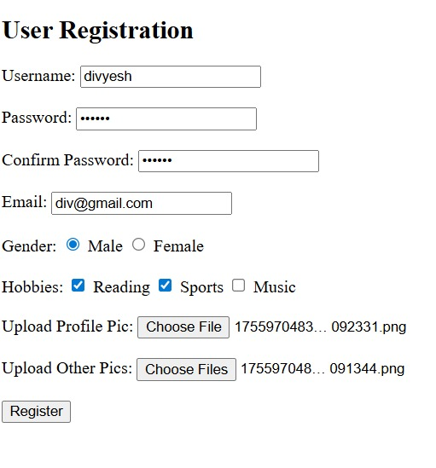

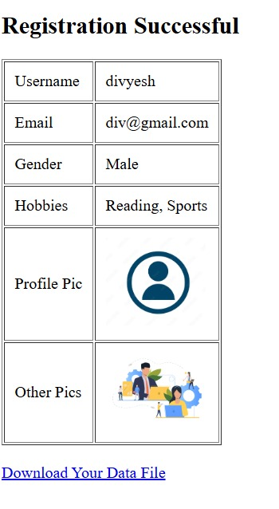

1. **ExpressLoginapplicationwithfilesessionstore.**

# OUTPUT:

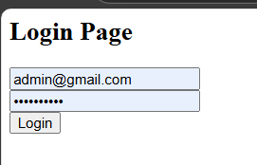

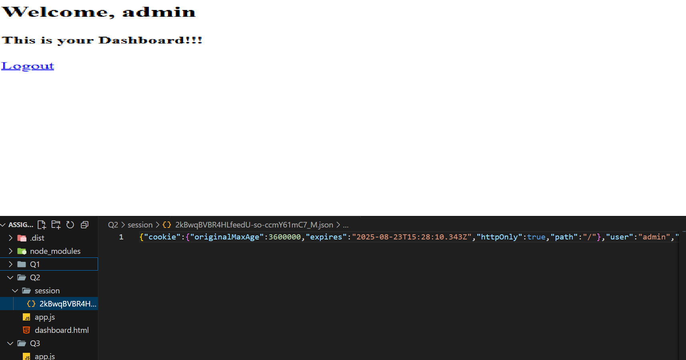

1. **ExpressLoginapplicationwithredissessionstore.**

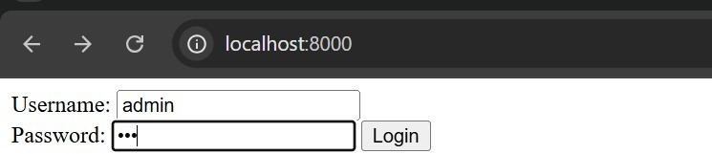

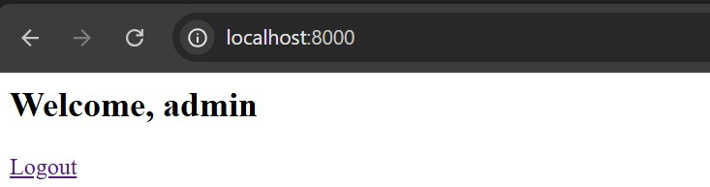

1. **DeveloploginforanADMINpanelofERPsystemwithsession,CRUDoperations for employees table (generate empid and password) with salary calculation with mongoose, express and EJS template engine. Send email to employee when**

inserted.Encryptthepassword.Logout. OUTPUT:

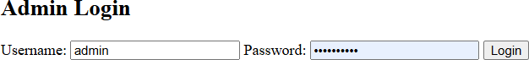

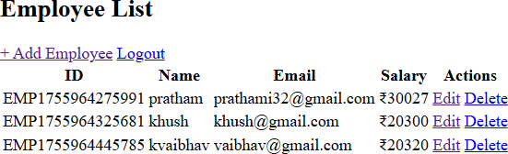

1. **Developemployee site (refer Q4 ) login with JWT, for employees with mongoose, expressandfrontend(html,css,javascript/jqueryJAMStack),-Page1)displayemployee profile . Page2) - Application for leave (fields date, reason, grant yes/no) Add, List - Logout.**

# OUPUT:

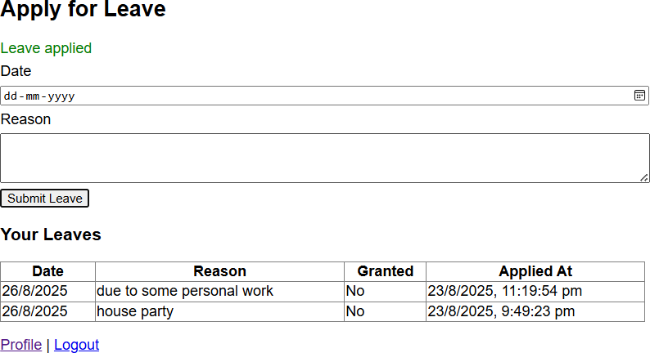

1. **Callanyfreeapifor ausefulutilityfromfrontendandbackend.**

# OUTPUT:

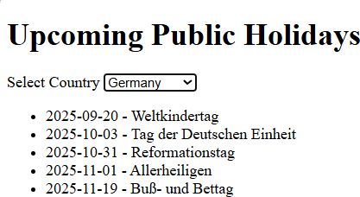

1. **Shoppingcartwithadminsiteandusersitewith(2level)Category andProducts.**

# OUTPUT:

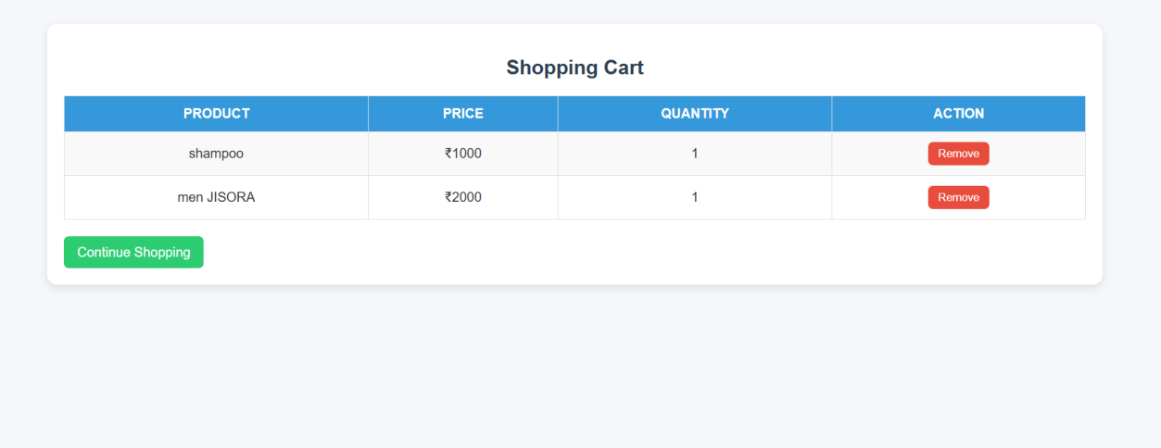

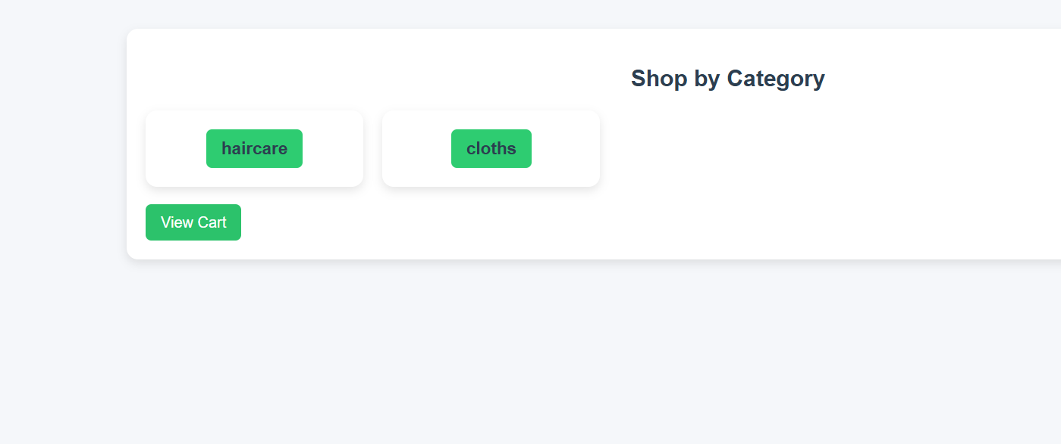

s

